**Sports Hub**



*Project Proposal*

Team - 6

Author:

Amarthya Sivakumar Annu

Team Members:

Austin Peterson

Yingjian Wang

Amarthya Sivakumar Annu

Department of Computer Science and Engineering

Texas A&M University

11/08/2019

Table of Contents

1 Executive summary

2 Introduction

2.1 Problem background

2.2 Needs statement

2.3 Goal and objectives

2.4 Design constraints and feasibility

3 Project Plan.

3.1 Planned Scope

3.2 Planned Report Authors

4 Proposed work.

4.1 Evaluation of alternative solutions

4.2 Design interface sketch

5 Engineering standards.

5.1 Project management

6 Appendices

6.1 Product backlog.

6.2 Burn-down chart

**1** **Executive summary**

With the basketball season around the corner we realized that it would be interesting and useful to have an application that was a place where the basketball fans could collect all the information they need. Our goal is to create an application that would be a one stop place for the fans to know all the information like the game schedule, the place to buy tickets, where to watch videos, what people are saying about the match on social media. We will be using 3 API,s - NBL, Twitter and SeatGeek to achieve this. We would like to extend this application for all the sports in the future.

# **2** **Introduction**

## **2.1** **Problem background**

There is a lot of information on the internet about a sport on the internet today. But it is usually difficult to find the information that we need in the same place. Similarly, even though all the information for a particular sport (basketball) are available, it is difficult to find everything in the same place.

## **2.2** **Needs statement**

Our website will bring together all the information about basketball that the fans are looking for in the same place. It is difficult to find all the information a football follower needs in the same place. The person has to navigate through several websites to book tickets, to know what everyone is saying about the game, or to know information about the games.

## **2.3** **Goal and objectives**

The goal of our website is to make it easy for the followers to know everything they need to know about the game. It would be much easier to book tickets, look up videos or any information they want to know about the team, or game in an instant and also know what others opinions about the game.

**2.4** **Design constraints and feasibility**

One of the main constraints to accomplish what we have planned will be the time. Since we only have a maximum of three weeks, it might be difficult to completely finish the website the way we want.

# **3** **Project Plan**

## **3.1** **Planned Scope**

We are using three API’s. We will be using the NBL API to get information about the games, players and rankings. We will use it to display the hottest games in our home page. We will also be using this to show information about the upcoming games and also information about each game. We are using the seatgeek API to help users book tickets for a game that they want to watch. We will finally be using the twitter API to show users what others are speaking about the game that they are interested in. Our fallback goals would be to not display the rankings, and our stretch goals would be to do the website for 2 more sports.

## **3.2** **Planned Report Authors**

The Initial Design report - Amarthya Siakumar Annu

A User Study Proposal and User Stories report. - Austin Peterson

The User Study Results and Design Change report - Yingjian Wang

The Team Retrospective report. - All the members.

# **4** **Proposed work**

## **4.1** **Evaluation of alternative solutions**

* Build a website that collect the information (past game score, place, future game information etc.) from various websites automatically and gather them together to have a new look. The pros is that once we build the web, no need for us to manually update the information about games. However, it’s technically hard to grab the specific information we need from different websites. And we have to consider that the website’s structure of our source may change in the future which may lead to collect wrong information or expired link.
* Build a website that manually collect the information we need from all kinds of sources by ourselves. Update the information on the website frequently and periodicity. The pros is that we can ensure the correctness of the information we update. The cons is that the efficiency can be low and the time and effort we need to keep the information new are much.

## **4.2** **Design interface sketch**

# 

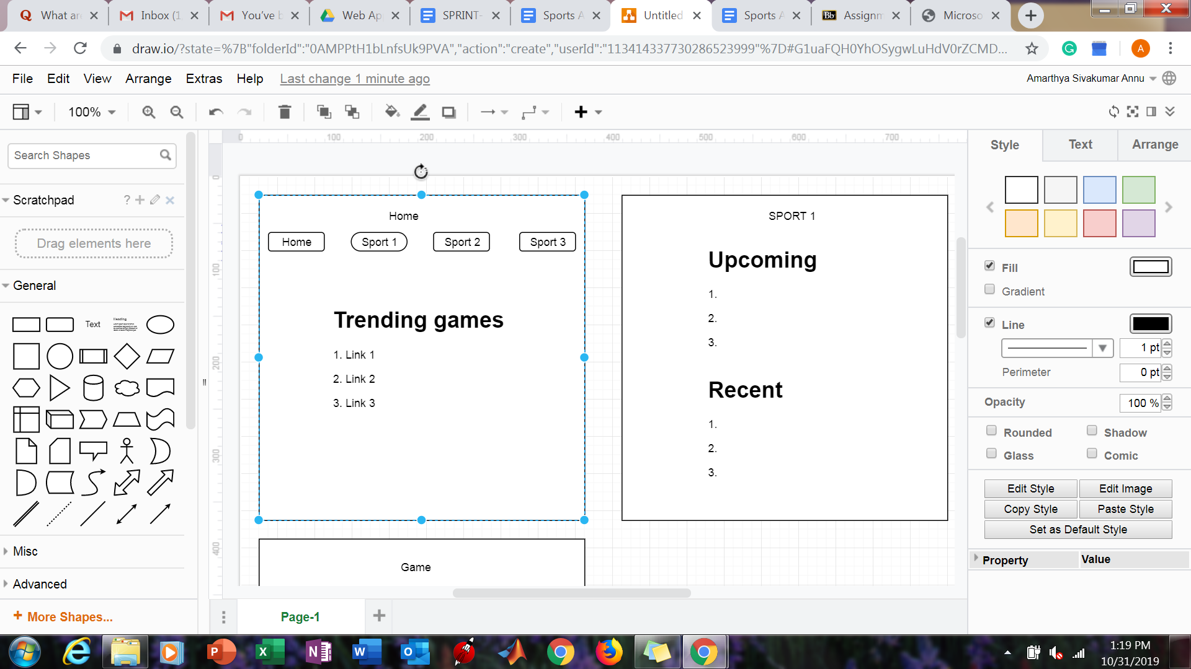

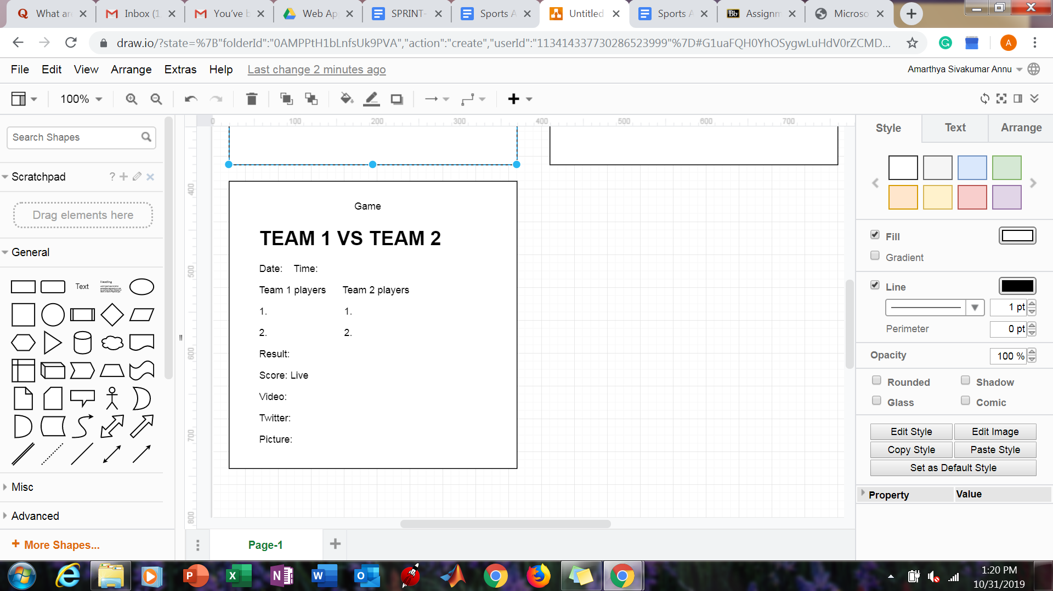

# 

# **5** **Engineering standards**

## **5.1** **Project management**

Our team has a variety of backgrounds that makes each member suitable for certain roles. Amarthya is acting as the scrum leader/team manager, keeping track of deadlines and documentation. As Austin has a background in web development, he is in charge of software and systems design. Yingjian is in charge of testing as well as technical reporting, in addition to helping with the front end design.

To manage the project our team meets regularly, both online and in person, to catch each other up on our progress and discuss what needs to be done before our next meeting. If in person, we usually meet in the Zachary engineering building during our lecture/lab and usually for a while afterwards. We keep track of our backlog and our progress during these meetings and reflect on what we've done and what we still need to do.

|  |  |  |  |
| --- | --- | --- | --- |
| Scheduled meeting times | | | |
| (Lab and lecture periods) | | | |
| Tuesday | | | 10:30 AM -12 PM |
| Thursday | | | 2:30 PM -4 PM |
| Friday | | | 12:30 PM -1:30 PM |

# **7** **Appendices**

## **7.1** **Product backlog**

Green - All three members

Red- Amarthya Sivakumar Annu

Blue - Austin Peterson

Yellow - Yingjian Wang

---------------------------Initial Design---------------------------------

1. Brainstorm application ideas
2. Make a final design decision
3. Discuss requirements
4. Create product backlog
5. Create a burndown chart
6. Create a design document
7. Sketch initial design
8. Delegate jobs (writing reports, PM)
9. Design Sprint 1 backlog
10. Determine code methodology/language
11. Delegate backlog tasks
12. Make official design drawings
13. Complete SCRUM documentation for this sprint

--------------------------------Sprint 1----------------------------------

1. Brainstorm application ideas
2. Make a final design decision
3. Discuss requirements
4. Create product backlog
5. Create a burndown chart
6. Create a design document
7. Sketch initial design
8. Delegate jobs (writing reports, PM)
9. Design Sprint 1 backlog
10. Determine code methodology/language
11. Delegate backlog tasks
12. Make official design drawings
13. Determine website creation method (template, pure HTML/CSS, website element designer)
14. Planning for the user study
15. Coming up with user stories
16. Create the website files
17. Create site navbar
18. Create upcoming games section
19. Create a recent games section
20. Add league/sport pages
21. Add league/sport logos
22. Implement interactive aspects (scrolling, dynamic game block creation)
23. Search for the APIs
24. Choose the appropriate APIs
25. Format API return data
26. Link API data with website elements (game blocks)
27. Filter hot games for “home” page
28. Filter games by sport for sports pages
29. Get images for each game block
30. Design game block link page

--------------------------------Sprint 2----------------------------------

1. Turn in sprint 1 retrospective
2. Create sprint 2 backlog
3. Create sprint 2 initial burndown chart
4. Design game block link page
5. Continue to build product backlog
6. Link recap video (through API?)
7. Format game time data
8. Format game date data
9. Format teams involved data
10. Retrieve player data
11. Algorithm to show team rankings.
12. Create twitter feed website section
13. Learn twitter api
14. Get access to twitter API
15. Link twitter API
16. Filter the tweets.
17. Find function to fetch the feed.
18. Decide what to show
19. Decide on how to form hashtags to search.
20. Display the tweets.
21. Front end to display twitter feed.
22. practice/familiarize with javascript
23. Integrate javascript code into website
24. edit/develop javascript
25. Include previous game data if multiple games played in a series (fallback)
26. Format final score data
27. Format score throughout the game data (by quarter, inning, etc)
28. Add design elements - pictures
29. Add general team data
30. Include next game between the teams if possible (fallback)
31. Add key moments/highlights from the game
32. Add MVP data if possible (kind of the same as above)
33. Team color code
34. Complete SCRUM documentation for this sprint
35. Design user study
36. Start user testing
37. Collect user data/feedback
38. Complete user study report
39. Make appropriate changes based on user feedback
40. Learn seatgeek API
41. Link seatgeek API
42. Front-end for booking tickets
43. Display link to booking tickets
44. Try to make it possible to buy tickets on the applications itself
45. Is it possible to display booked seats?
46. Try to make it possible to choose seats.

--------------------------------Sprint 3----------------------------------

1. Conduct sprint - 2 retrospective survey
2. Finish sprint - 2 retrospective
3. Create sprint - 3 backlog
4. Find API’s for two other games
5. Front end for two other games
6. Create a new page that combines information from all three games
7. Incorporate information from the other two games also on the existing code.
8. Start filter by team process (search for a team, get data for their games)
9. Create a modified sport page for individual teams
10. Find team info API
11. Link team info with team page
12. Develop search function for teams
13. Make search results page
14. Build team player grid(?)
15. Finish team pages
16. Clean up site/make final design changes
17. Test links/pages.
18. Try to make the website mobile friendly.
19. Check and link work of all members.
20. Clean up.
21. Make project burndown chart
22. Make sprint burndown chart
23. Analyze stretch and backfall.
24. Create project presentation.
25. Finish team retrospective.

## 

## 

## 

## 

## 

## **7.2** **Burn-down chart**

